**Scenario**: You are given the task to test out a new area of the website that gives the user a snapshot of important information once they login. You are given both an image of the design and acceptance criteria / requirements. Please review them below:

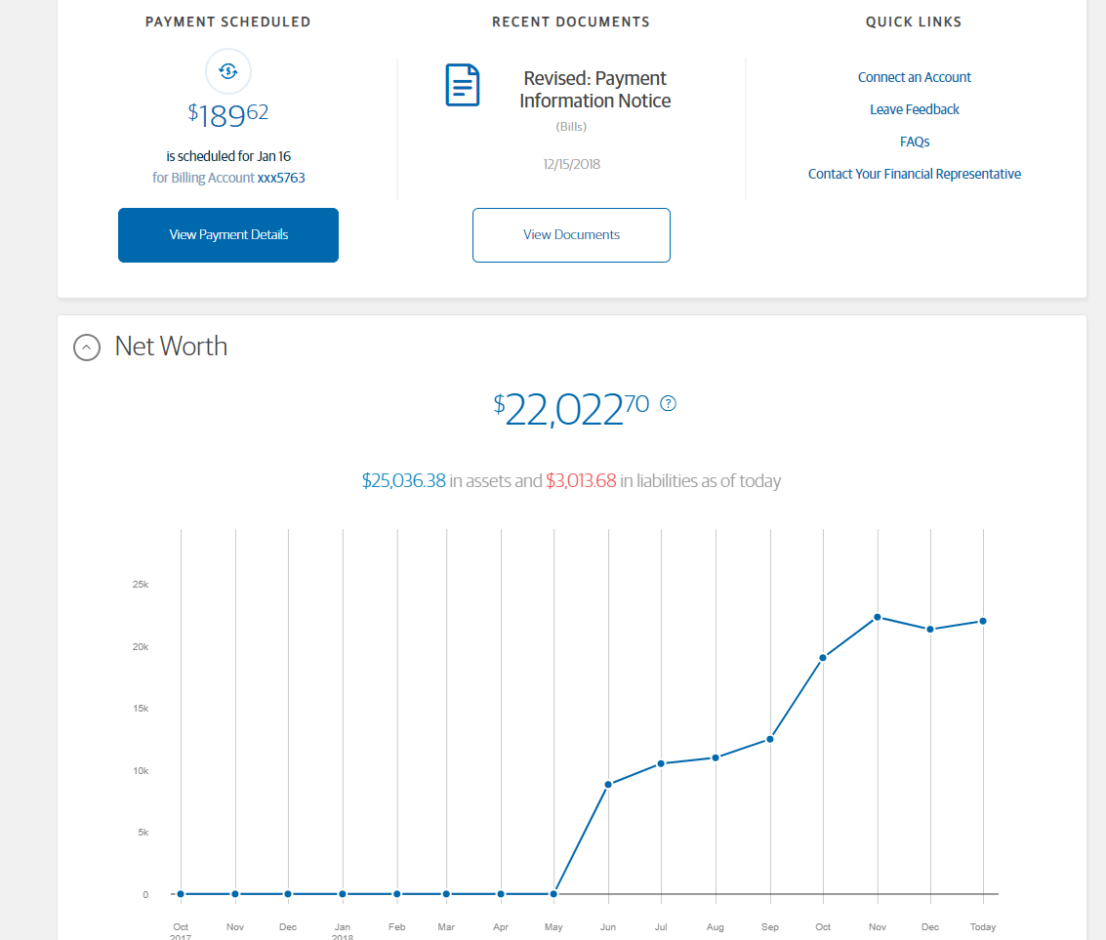

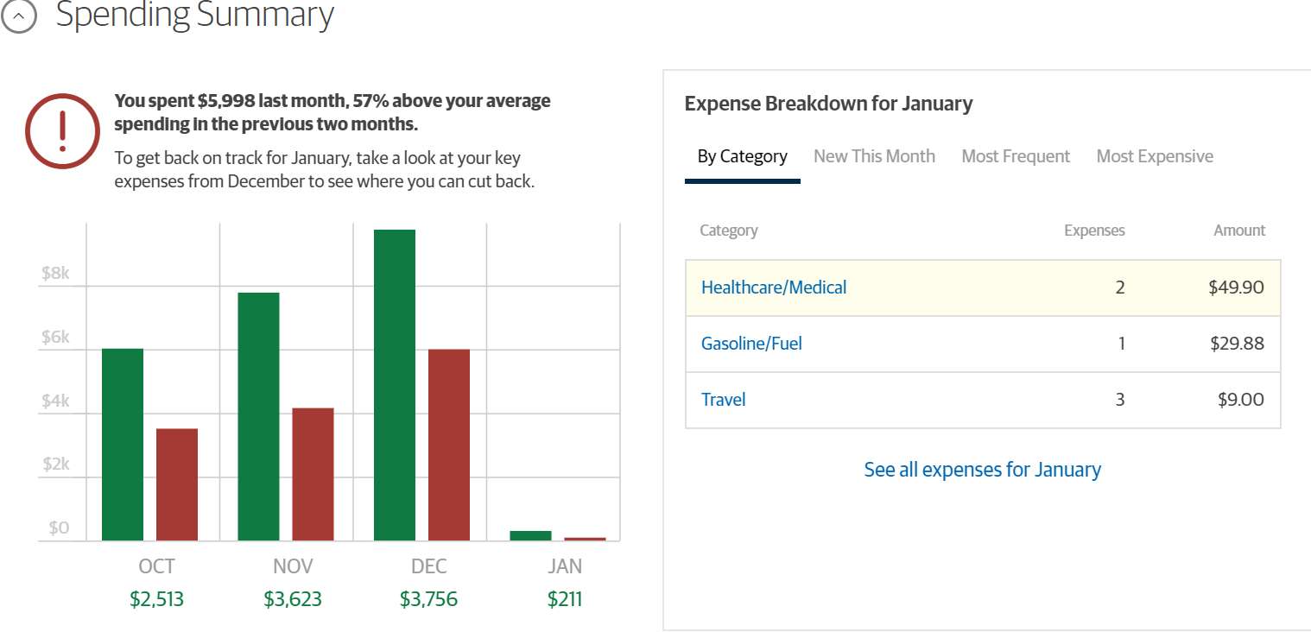

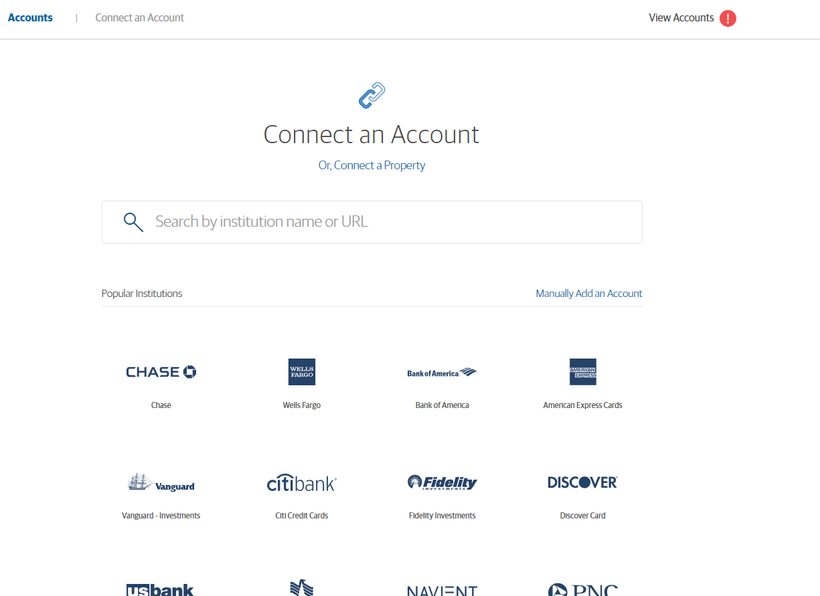

**Acceptance Criteria / Requirements:**

When user logs in he/she should be able to see his Net worth

There should be graphical representation on monthly basis on the Net worth

User will be presented with upcoming payment schedule

User will be provided a deep dive on income vs spending for last 4 months

User should be presented with view where in current month expenses are rightly categorized

User should be able to add his account(s) from the list of popular institutions

User should also be able to add account(s) manually

User should be able to remove account(s) already added

User should be notified in case there are issues with account(s) which are already added

**Task 1** : Write a list of questions or uncertainties you may have that you would ask a designer or stakeholder concerning the image or acceptance criteria/requirements.

**Task 2** : Write a list of data or users in a certain state that you may need to properly test this.

**Task 3** : Write a list of high-level test scenarios that you can think of based only on the design and acceptance criteria you are given. After you list them out, number them in terms of priority (1 - must test, 2 - should test, 3 - test only if there is time).

**Task 4:** Imagine that you find a defect while testing the above. Write a sample defect report below:

**Task 5:** What scenarios would you consider valid for automation? Why?